OXY-FUEL

CUTTING

OXY-FUEL CUTTING

Of all the skills and processes that are learned by welders and metal fabricators, oxy-fuel cutting is the least understood and mastered and the most improperly used.
Not enough time is devoted to oxy-fuel cutting in most welding classes for students to master these skills, or oxy-fuel cutting takes a back seat to learning the different welding processes. With the recent increase in popularity of the plasma arc cutting process, even less time is devoted to oxy-fuel cutting in many welding courses.
Another common problem is that many people are shown how to use a cutting torch by a person who doesn’t know how to use the torch correctly, or doesn’t understand the mechanics and parameters that affect the quality of the cut.
There is a belief held by many people that a straight, clean cut cannot be made with a cutting torch. Also many people have the attitude that it isn’t important to produce a clean accurate, slag free cut, because any defects can be removed with a grinder.
Welders and fabricators need to understand that any unnecessary post cut clean-up such as excessive grinding adds to the cost of fabrication. Remember, grinders and grinding wheels cost money. Also, grinding takes time and time is money. If parts to be assembled by welding are inaccurately cut, the welding time is going to be increased and again will add to the cost of production.
The information and guidelines presented in this chapter should be read and understood. The lab assignments should be done correctly and cutting skills should be developed in order to make you a more employable and productive person.

The Oxy-Fuel Cutting process is used to flame cut carbon steels and some low alloy steels. The cutting is accomplished by heating the steel to its kindling temperature. A stream of pure oxygen is then directed at the pre-heated area which will actually burn (rapidly oxidize) the steel. The kindling temperature of a metal is the lowest temperature at which a material will burn. The kindling temperature of carbon steel is approximately 1725°F to 1750°F.
The pre heating is accomplished by the combustion of a fuel gas and pure oxygen. There are fuel gases other than acetylene such as propane and natural gas that can be used for this cutting process, but for the purposes of this textbook we will concentrate on the oxyacetylene cutting process.
The skills acquired in learning oxyacetylene cutting can be applied to other types of oxy-fuel cutting (OFC). If a fuel gas other than acetylene is to be used, it is important that the torch to be used can be used with the other fuel gas and that you use the correct type of torch tip for the fuel gas that is to be used. Note: Cutting tips designed to be used with acetylene cannot safely be used with other fuel gases.

Safety Equipment
- Safety Glasses
- Oxyacetylene Welding/Cutting Goggles equipped with a #4 or #5 shaded lens
- Leather Gloves
- 100% cotton or wool long sleeve shirt and pants or coveralls
- Leather work shoes or boots

OXYACETYLENE CUTTING SAFETY
It is as important to follow safety procedures while using the cutting torch as it is to follow the safety procedures for any welding process.
Proper clothing must be worn. Although the oxyacetylene cutting process does not produce ultra-violet light, it does produce infrared light in the form of heat. Hot sparks are given off and it is important to protect yourself from these sparks as well as the molten metal being removed during the cutting process. There is not as much visible light produced either, but without the use of the proper shade of lens in the cutting goggles it will be difficult to see the cutting well enough to guide the torch properly.
If possible, remove any flammable materials from the cutting area. The molten metal that is being removed can travel several feet, especially when the torch tip is pointing in a direction other than straight down. If there are flammable materials within 35 feet of the cutting there should be a fire watch present. When cutting with the torch, as with any welding process, it is important to have a fire extinguisher or a source of water close by to extinguish any fires that may start. More fires have been started with a cutting torch than with all welding processes combined.
If you are cutting on used materials, it is important to know what the material was used for. It may have been in contact with toxic or combustible materials that may either give off dangerous fumes or there may be enough combustible residue left to start a fire or cause an explosion. This is particularly important when cutting on used containers such as tanks, barrels, and pipe. If you are not sure what a container has been used for, then it should be properly cleaned before any cutting is done. Never cut on a sealed container. All containers have to be vented.

If you are going to cut on metal that has a protective coating on it, you must have proper ventilation. Coatings such as paint, cadmium, or galvanizing, which is a zinc coating, produce toxic fumes. Do not breathe these fumes. These fumes should be exhausted from the cutting area or the operator should wear the proper type of respirator in order to be protected from these fumes.

OXYACETYLENE CUTTING EQUIPMENT (Figure 1)
The same basic equipment that is used for oxyacetylene welding is used for oxyacetylene cutting. A list of the equipment would include:
- Oxygen and Acetylene gas cylinders
- Oxygen and Acetylene gas regulators
- Oxygen and Acetylene hoses
- A cutting torch or a combination torch with a cutting attachment
- Cutting Tip (Figure 2)
- Striker to light the torch
- Tip Cleaners

OXYACETYLENE EQUIPMENT – SET-UP
If the cutting equipment has not been set up, you should refer to Chapter 3, Oxyacetylene Welding, and follow the procedure for setting up the equipment.
Check the oxygen and acetylene regulators. The adjusting screws should be backed off sufficiently to prevent a sudden burst of high pressure gas from damaging the regulators. The torch oxygen and acetylene needle valves should also be closed. Note: If a combination torch is to be used, the torch oxygen valve closest to the hose fitting is opened all the way and left open.
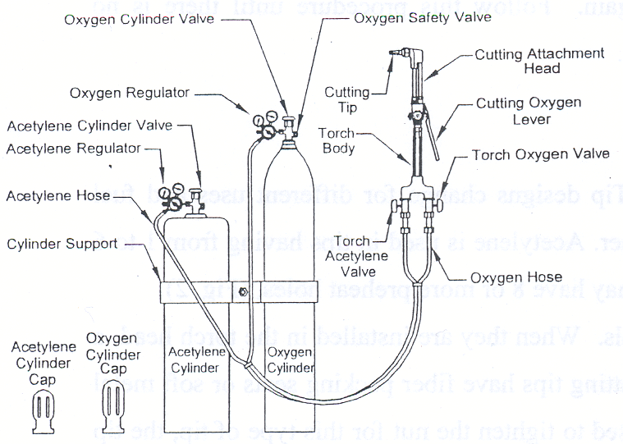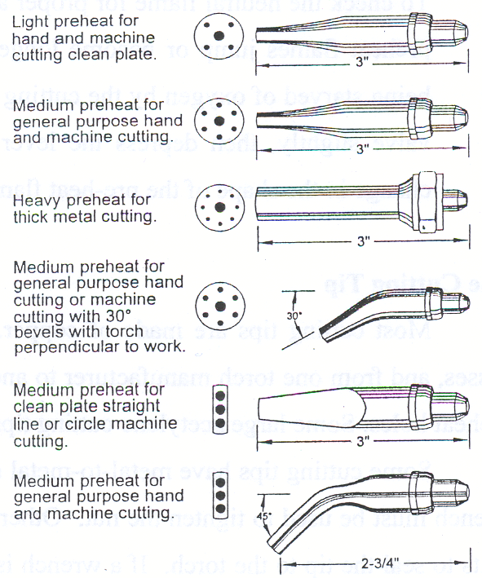
Figure 1 Figure 2
Adjustment of the pre-heat flame is done with the oxygen valve located on the cutting attachment. Open the oxygen cylinder valve all the way. Open the acetylene cylinder valve no more than 1½ turns. Adjust the regulators to the proper setting for the size of tip to be used.

Lighting The Torch
- Open the torch acetylene needle valve approximately ¼ to ½ turn. Light the torch and adjust the flame to where there is very little or no black smoke being produced.
- Open the oxygen needle valve slowly until the inner pre-heat flames have a distinct cone shape, (Figure 4). This is a neutral flame. You must use a neutral flame to produce quality cuts.
- To check the neutral flame for proper adjustment, depress the cutting oxygen lever. If the preheat flames jump or become longer, it is an indication that the pre-heat flames are being starved of oxygen by the cutting oxygen. If this is the case, open the torch oxygen valve slightly, then depress the lever again. Follow this procedure until there is no change in the shape of the pre-heat flames.

The Cutting Tip
Most cutting tips are made of copper. Tip designs change for different uses and fuel gasses and from one torch manufacturer to another. Acetylene is used in tips having from 1 to 6 preheat holes. Some large acetylene cutting tips may have 8 or more preheat holes, (Fig. 2).
Some cutting tips have metal-to-metal seals. When they are installed in the torch head, a wrench must be used to tighten the nut. Other cutting tips have fiber packing seats or soft metal seats to seal the tip to the torch. If a wrench is used to tighten the nut for this type of tip, the tip seat may be damaged.
When removing a cutting tip, if the tip is stuck in the torch head, tap the back of the head with a plastic hammer, (Fig 3). While doing this, hold the tip in your hand to keep it from dropping to the floor and becoming damaged. Do not use a metal hammer. Any tapping on the side of the tip may damage the seat.
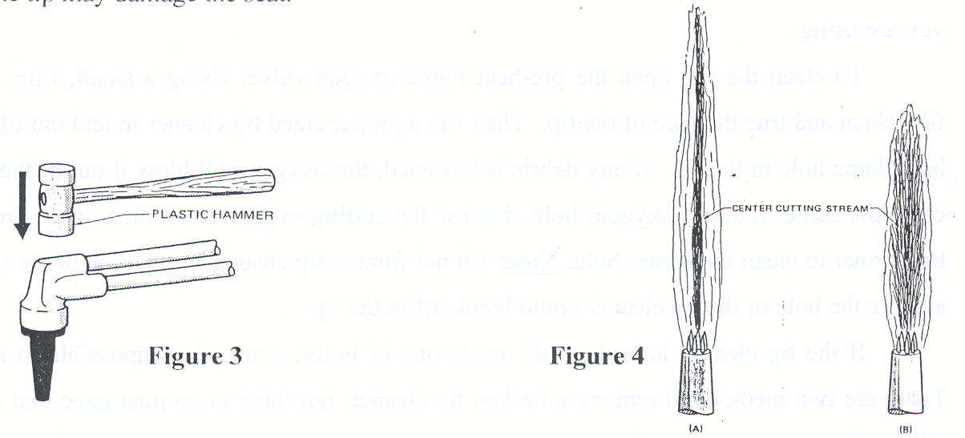

To check the assembled tip for leaks, hold your thumb over the end of the tip, turn on the torch oxygen valve and spray the tip with a soapy water solution. If bubbles appear, there is a leak. If the torch leaks loosen the nut, turn the tip slightly, and then retighten the nut. Re-check for leaks. If the torch-tip connection still leaks, remove the tip and inspect the seating surfaces on both the torch and the tip. If the tip is damaged it should be replaced with another tip. If the torch seats are damaged, the torch will have to be repaired by a qualified service technician.

Cleaning the Cutting Tip
No matter how careful you are with the cutting torch, the tip will eventually become dirty. This condition can be caused from small particles of mill scale popping loose from the surface of hot rolled steel, overheating the steel while cutting or, cutting on dirty or rusted steel. Before any cutting is started, it is important to have a clean tip. Using a dirty cutting tip will create slag on the bottom edges of the cut and a wider kerf. Before lighting the torch, look at the face of the tip. If it looks dirty then it is dirty and should be cleaned. After lighting the torch, adjust it to a neutral flame. Look at the shape of the pre-heat flames. If any of the preheat flames are irregularly shaped, the tip needs cleaning.
Even if all the pre-heat flames have the proper shape, depress the oxygen lever. If the outer or secondary flame becomes very short, the tip needs to be cleaned. Note: Using an excessively high oxygen pressure may also cause the secondary flame to shorten, (Figure 4). Make sure that you are using the correct oxygen and acetylene pressures for the size of tip that you are using.
To clean the tip, open the pre-heat flame oxygen valve. Using a small, fine, single cut file, clean and true the face of the tip. Then run a proper sized tip cleaner in and out of each pre-heat flame hole in the tip. If any debris is loosened, the oxygen will blow it out of the hole. To clean the center (cutting oxygen) hole, depress the cutting oxygen lever then, use a proper sized tip cleaner to clean the center hole. Note: Do not force a tip cleaner into a hole in the tip. It will enlarge the hole or the tip cleaner could break off in the tip.
If the tip cleaner is broken off inside one of holes, it may be impossible to remove it. There are two methods to remove a broken tip cleaner, but there is no guarantee that either one will work.
Method 1: Remove the tip from the torch. Using a long tip cleaner inserted into the back side of the affected hole, push the broken tip cleaner out through the face side of the tip.
Method 2: Using a small, fine, single cut file, remove enough of the tip face around the tip cleaner to expose the end of the tip cleaner. Grab the tip cleaner with a pair of pliers and pull it out of the hole. Once the broken cleaning wire is removed, file the face of the tip flat.

Cutting Procedure
Before the actual cutting begins, a reference or guide line should be marked on the metal. This line should be thin and accurate and should be done with a piece of soapstone that has been ground to a very thin chisel edge at the end. If the cut is to be straight, use a straight edge as a guide for the soapstone. If a circle is to be cut use a set of dividers that will hold the soapstone or use an accurate template as a guide. Taking the time to accurately lay out the cutting lines will save you time later by reducing or completely eliminating any post cutting grinding to produce a smooth edge.

Starting the Cut (Straight Cut on Plate)
- Once the torch is lit and a neutral flame has been obtained, make a false cut. In other words, move the torch along the guideline without depressing the cutting oxygen lever. If you are using a cutting torch with long barrels place one hand inline with the end of the cut and slide the barrels between your thumb and index finger while pulling the torch towards you with your other hand. This is done to make sure that the cut can be completed without the cutting head of the torch running into the hand that is guiding it. This false cut will also let you know if you are in a comfortable position throughout the entire cut. You need to be in a comfortable position in order to make a smooth, accurate cut, especially if several cuts have to be made.
When using a combination welding/cutting torch, make the cut going across in front of you. If you are right - handed, move the torch from right to left. If you are left – handed, move the torch from left to right. Using this technique will allow you the best view of the cutting process. This will only allow you to make a short cut without moving the hand that is guiding the torch. If a long cut is to be made get in the habit of sliding your guiding hand lightly across the plate.
- Position the torch to where the ends of the pre-heat flames are over the edge of the metal and are approximately 1/16 to ¼ inch above the metal. The distance between the end of the preheat flames and the metal being cut is known as the coupling distance. When cutting thin metal with a small tip, the coupling distance will be closer to 1/16 inch. When cutting thicker metal with a larger tip, the coupling distance should be closer to ¼ inch.
- Heat the edge of the metal until it becomes hot enough to turn to a orange color. This indicates the metal is at its kindling temperature.
- Slowly depress the cutting oxygen lever completely. The cutting should start, and the cut metal should be blown out the back side of the metal to leave an open space as the cutting progresses. The space or slot that is left between the two pieces of metal is known as the kerf, (Figure 5). The kerf should be very narrow. The thinner the metal that is being cut, the narrower the kerf should be. If the kerf is wide compared to the thickness of the metal, something is not correct with the process, such as using too large of a tip, a dirty tip, or the travel speed is too slow. If the cutting progresses satisfactorily, leave the cutting oxygen lever depressed until the end of the cut. If the lever is released, the cutting will stop.
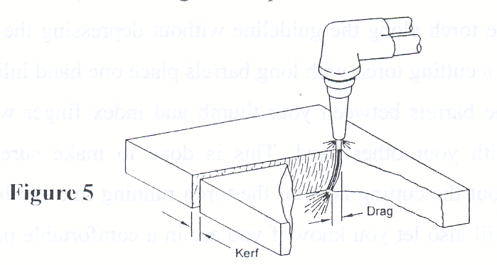

Drag: The distance between the cutting action at the tip and the bottom of the kerf is called drag. When the oxygen stream enters the top of the kerf and exits the bottom of the kerf directly below, the drag is said to be zero. If the cutting speed is increased (or the oxygen flow decreased), oxygen in the lower portion of the kerf decreases and the kinetic energy of the oxygen stream drops slowing cutting action in the bottom of the cut. This causes the cutting action at the bottom of the kerf to lag behind the cutting action at the top, (Figure 5). Excessive drag can cause loss of cutting action in thick cuts and restarting the cut may be necessary. Whenever a cut has to be restarted, there is always the possibility of increasing the width of the kerf (gouging) at the restart point.
- The cutting travel speed should be as fast as possible without creating excessive drag or loosing the cut or cutting action. This will give you the smoothest cut. If for some reason the cutting process stops, you must release the cutting oxygen lever and preheat the edge of the metal where the cutting stopped and then depress the oxygen lever to restart the cutting procedure again. If you try to restart the cut with the cutting lever depressed without first preheating where the cutting stopped, the cutting oxygen stream may actually cool the metal off and the cutting will not continue.
- On most cuts, there will be some slag or dross on the bottom sides of the kerf no matter how well the cut is done. If the torch is held so that the tip is angled just slightly to the scrap side of the cut, the slag will be placed on that side, (Figure 6).
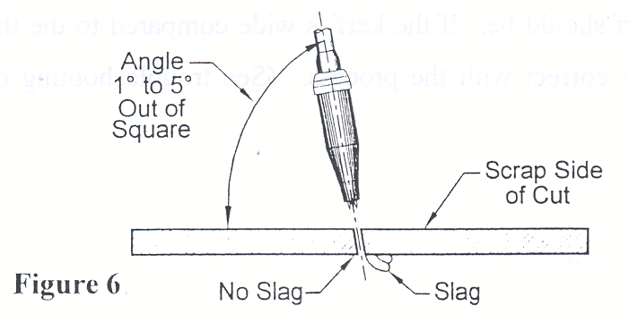

If a bevel is to be cut, (the cut is made at an angle), the above procedures are followed with the cutting tip directed at the angle to be cut. When cutting a bevel, more metal has to be removed than if the cut was straight through, with the tip held perpendicular to the work-piece. It may be helpful to preheat along the cutting line with the torch, before the cut is started. It may also be necessary to use a slower travel speed when cutting a bevel as compared to the travel speed used to make a cut with the tip perpendicular to the work-piece surface.

Piercing a Hole
When it is necessary to start the cut away from the edge of the metal a hole has to be pierced through the metal to start the cut.
- Mark the cutting line clearly
- Position the tip so that the cut begins away from the cutting guide line onto the side of the cut that will become the scrap or piece of metal that is not going to be used.
- When the steel reaches its kindling temperature, depress the oxygen lever slowly while raising the tip slightly. This is done because as the metal starts to melt, it will have a tendency to rise up towards the cutting tip until there is a hole cut completely through the metal. If the oxygen lever is depressed quickly the force of the oxygen stream will cause the molten metal to pop up. When this happens, the molten metal can become stuck to the end of the cutting tip, clogging the holes which may cause a backfire or even a flashback. The operator may also be covered with a shower of hot sparks.
- Once the hole is pierced completely through the steel, depress the cutting oxygen lever completely, lower the tip to the proper coupling distance and proceed with the cut, (Figure 7).
- Cut in a spiral motion out to the guideline, then follow the guideline until the cut is completed, (Figure 8).
- Be aware of the tip angle as the cut proceeds. Remember, the torch cuts at whatever angle it is held at.

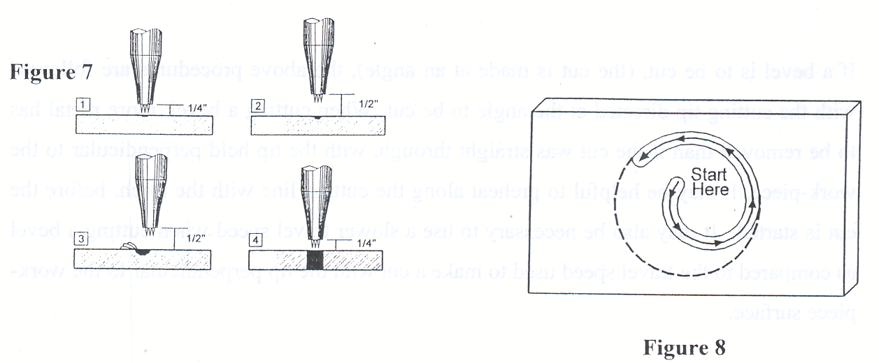
Cutting Pipe
When cutting pipe, it is usually necessary to start the cut away from the edge. If this is the situation, follow the above guidelines for piercing a hole to start the cut. Again it is important to have an accurate, thin, guideline to follow. There are tools available to aid in drawing cutting guidelines on pipe (fig.?). Once the cut is begun, keep the tip pointed towards the center of the pipe and be aware of the tip work angle. Try to place yourself in a comfortable position. It is also important that you don’t stand at the end of the pipe. Sparks may come out of the end of the pipe and you may get burned.
One of the best methods to use when cutting pipe, is to start the cut at the 3 o’clock position, and then cut as far as you can towards the 12 o’clock position. Stop the cut; roll the pipe in a direction to where the end of the cut is now at the 3 o’clock position. Again start the cut and proceed towards the 12 o’clock position. Follow this procedure until the cut is completed.

Cutting Solid Round Stock
Cutting solid round stock with a torch isn’t the best way to cut round stock, but then there are times when there are no alternative methods.
- Draw a guideline. The cutting tip will be kept in a vertical position throughout the cut.
- Light and adjust the torch to a neutral flame.
- Position the torch to one side of the round stock.
- Place the tip to where the preheat flames are almost touching the surface of the round stock and is pointed towards the center of the round stock
- Once the kindling temperature has been reached, slowly depress the oxygen lever. When the cut is started, move the tip so that the cut continues down one side of the round stock and depress the oxygen lever completely.
- Continue the cut by raising the tip and moving it up and over the round stock. It may be necessary to point or angle the cutting tip slightly in the direction of the cut to prevent the bottom of the cut from lagging behind the top of the cut.
- When cutting larger diameter round stock it may be helpful to preheat the round stock before cutting in order to get the cut to go completely through to the bottom.

Cutting Thin Metal
There are better and more precise ways of cutting metal 1/8 inch and thinner, but steel as thin as 20 ga. can be cut with the oxyacetylene cutting torch.
- Use the smallest cutting tip available.
- Hold the torch at a 15° to 30° angle to the metal surface to increase metal thickness to be cut, (Figure 9).
- Use the minimum preheat flame that will permit cutting.
- Tipping the torch 1° to 5° from perpendicular, away from the scrap side of the kerf will keep slag off the good part.
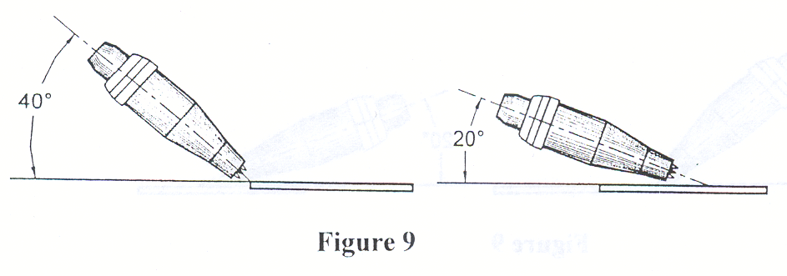

Things To Remember To Produce A Quality Cut:

- Use the correct size tip for the thickness of metal that is to be cut
- Set the oxygen and acetylene pressures for the size tip that is to be used
- Adjust the torch correctly to a neutral flame
- Use a clean tip
- Use the correct travel speed, tip angle, and coupling distance
- Move the torch as fast as you can without loosing the cut
- Always support the torch by placing the barrel between your thumb and index finger
- Use a guide whenever possible
- Stand in a comfortable position, feet apart
- Pay attention to what your doing

Victor Acetylene Cutting Tip Chart

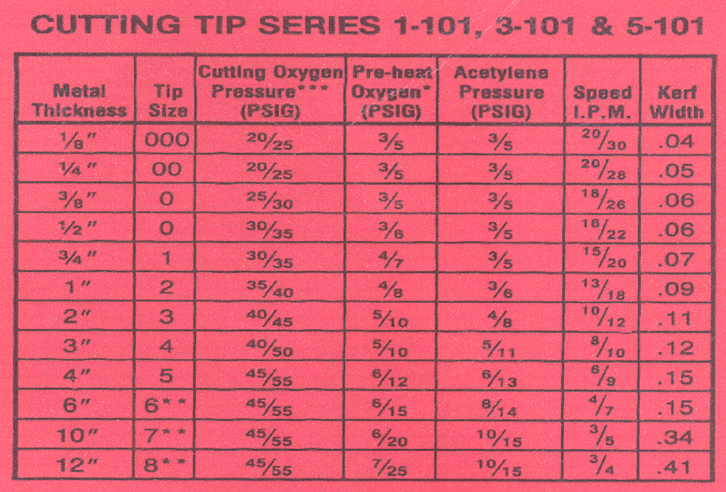
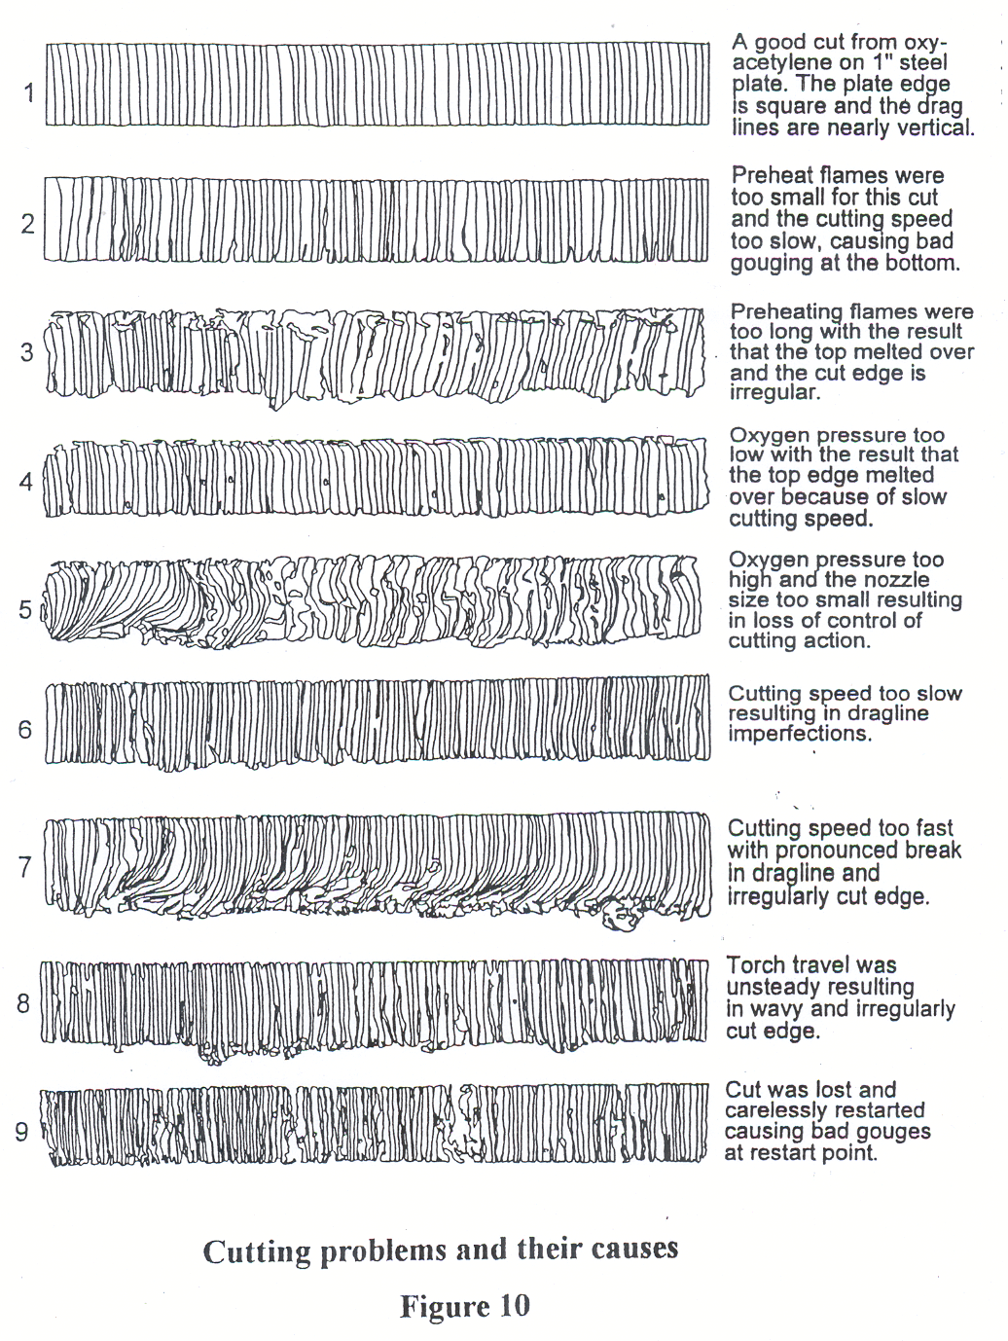

Credits
Figures 1, 2, 5, 6, 7, 8, 9, & 10; Welding Essentials, William Galvery and Frank Marlow
Figures 3 & 4; Welding Principles and Applications 4th ed. Larry Jeffus

