Ag Shop Skills Name:_________________
Mr. Meredith Period:_________
CONCRETE
What is Concrete?
- Concrete -
- Portland Cement -
- Mortar -
Why Concrete?

- _______________
- Insect and Rodent Proof
- Decay Resistant
- Highly Storm Resistant
- Wear Resistant
- ________________
- Strong
- _________________
- Easy to use with little expense
- _________________
- _________________
- Sanitary and easy to clean
- Easily Recycled
Why not Concrete?

- Wears away when exposed to moving water

Importance of Silt Test
- The ______________ ______________is key for looking at the __________ that will be mixed in with concrete ingredients.
- Ideally, you want a sandy loam or more ___________ soil.
- Sandy soil is helpful especially due to the ___________ and___________________ of concrete.
- If concrete doesn’t have this ability it can crack.

Silt Test
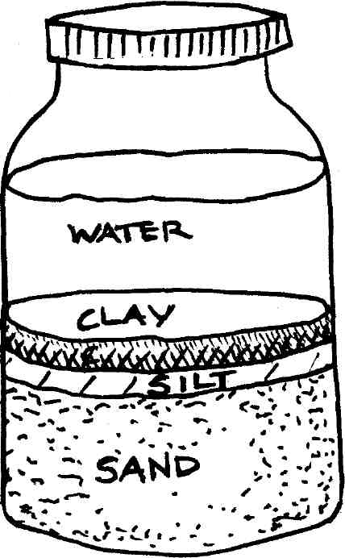

Mixing Concrete!
- You mix concrete to a _______________. The ratio is expressed in a 3 digit number called a ______________.
- EX: a 1-2-3 mix has 1 part cement, 2 parts fine aggregate (sand) and 3 parts coarse aggregate
Your goal for your ratio is to get a __________________ ______________
Workable Mix
- Refers to the ___________________ of the wet concrete after the carious ingredients have been mixed ____________________.
Characteristics of A Workable Mix
  - All _______________________ are clean
  - No dry powder is present
  - No ____________________
  - ____________________ in color
  - Every particle of aggregate is covered with ________________ paste
  - Mixture can be moved with a ______________________

Chemical Process
- Concrete goes through a chemical process known as ___________________
- Hydration – This is where the ___________ reacts with the cement, which _________ the other components together, eventually creating a ____________-like material.
Chemical Admixtures
- ___________________ – Speed up the chemical process of Hydration (CaCl, NaCl)
- _______________________ - Slow the hydration process down
- __________ ________________________– trap air bubbles in the concrete to reduce damage during Freeze/Thaw
- ______________________ – Changes the color

Estimating Materials
- Don’t want to spend money on extra or be short on a job. (both cost $)
- Order in ______________________ ________________________
- 1 cubic yard= ___________ cubic ____________________
- Formula
  - ______________________’ X ________________’ x _____________________’
    - You may have to convert ______________ to ___________ (divide by 12)
Example # 1

Always add an additional ______% to make sure you have enough. Since we cannot

order in half yards, round _____ to the nearest whole yard.

Example # 2

Formulas for Area

Triangle - ½ (______________ x ________________) x Thickness

Rectangle - _____________ x ________________ x ____________________

Circle - (3.14 x ______________) x ________________

Trapezoid - _________ + __________ x Thickness
_____________________
2

Practice Problems

Preparing for a Form
- __________________ – metal or wooden structure that ________________ the concrete to the desired shape or form until it hardens.
- _______________ or _________________– is the concrete _________ that provides a solid ____________ foundation for brick stone or black walls.

Constructing Forms
- Uses _____________, Clean, ___________________ lumber
- Sharpen ___________________ evenly so that they can be driven in with ease
- Place stakes__________ inches apart
- Drive _________________ through stakes (duplex Nails) are best
- Use wood sprayed with ________________________
- ________________ stakes allow you to put at desired height
- Transit or_______________ to determine desired ________________
- Average slope will be _____________” fall.

Making Joints
- _________________________ Joint – place where one pouring ____________ and another starts
- __________________ Joint – Is a _________________ break which permits concrete to ________________ and _____________________ without cracking. These joints are usually made with wood, galvanized metal or asphalt.
- Note – Control joints do not prevent concrete from _________________.

Reinforced Concrete
- Concrete can be strengthened by adding ____________ or _____________ mesh.
- As a rule of thumb you should lap bars______________ times the diameter.
- Ex. Rebar ½” should be put every__________ inches
- _____________” should be lapped every __________ inches
- Rebar should be at least ¾” from the surface. On average it is 1 ½” below the surface
Pouring Concrete
- Must have all tools ________________ concrete starts to set in ________ min.
- After spreading concrete you need to ___________________ it
- ___________________ – moving a ______________________back and forth to remove ____________ concrete
- Then you will need to ___________ your concrete.
- Tamping – this is the process of settling the rocks at the bottom of your project

Finishing
- Then you need to ___________________ your project
- ___________________ – bringing the __________ aggregate (sand) to the surface – this will make your concrete ______________.
- __________________ Finish – will leave your concrete _____________ so that you will not slip
- __________________ Finish - This will leave you with a _____________ finish (more aesthetic than structural)

Curing Process
- Curing is the amount of ____________ from consolidation to it reaches your desired _________________________
- Concrete takes hours to set but takes _____________ days to be cured!
- During this time it’s important to keep the concrete ____________________ so that you develop good _____________________ and strength.
- Strength increases with ____________!!!

